Lab Exercise 3- Working with Git Rebase
Lab Exercise: Git Rebase
This exercise demonstrates the use of git rebase in a scenario where no conflicts occur.

Objective
- Learn how to rebase branches when there are no conflicting changes.
- Understand the clean, linear history created by git rebase.

Prerequisites
- Install Git on your system.
- Initialize a Git repository:
Step-by-Step Instructions
1. Set Up the Repository

- Create the main branch and make the initial commit:
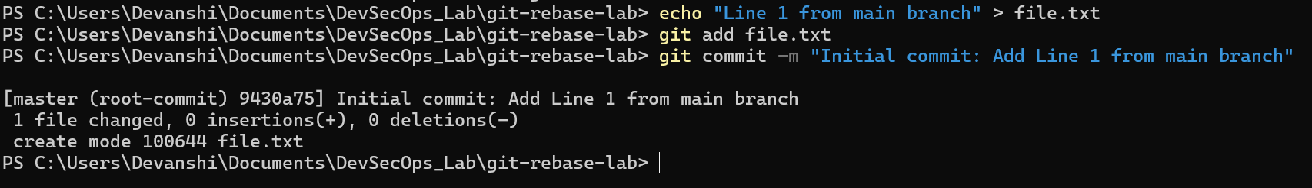
- Create a new branch feature-branch:
- Add a new line to file.txt in feature-branch:
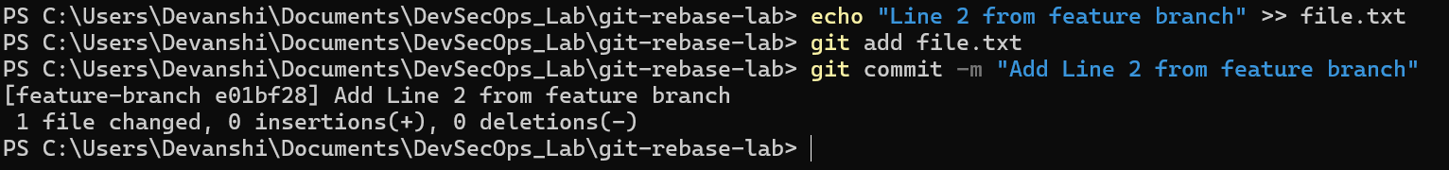
- Switch back to the main branch and add another line:
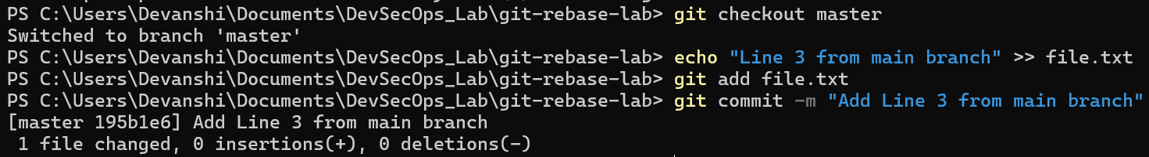
2. Rebase feature-branch onto main
- Switch to feature-branch:
- Rebase feature-branch onto main:
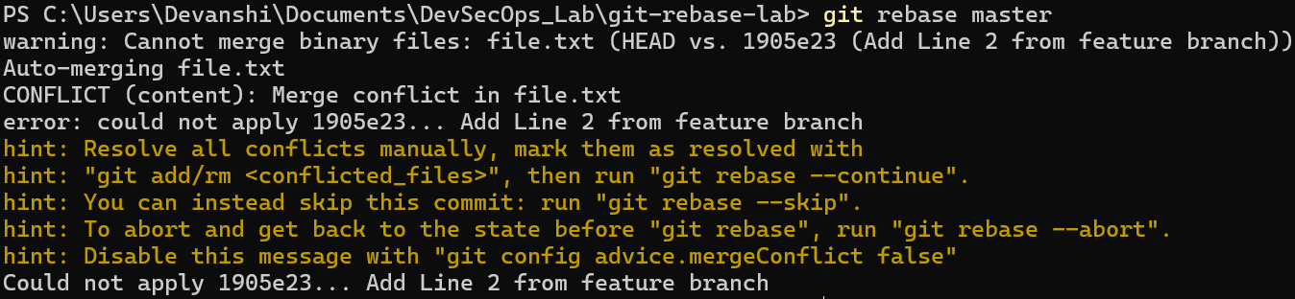

- Git will replay the commit from feature-branch onto the main branch. After resolving the conflict, the branch rebase successfully completes.
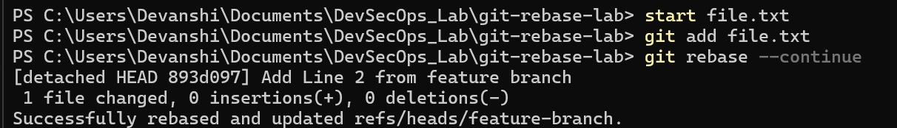

3. Verify the Rebase
- View the commit history:
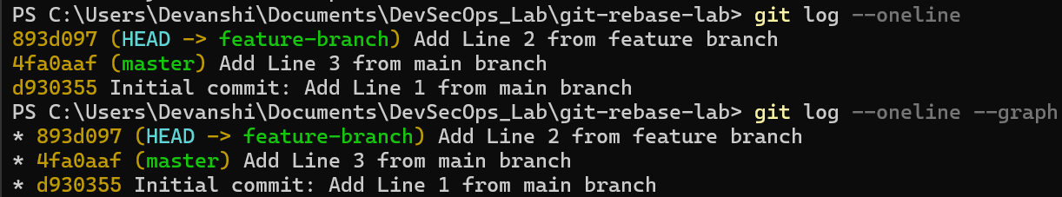

- Check the contents of file.txt:
